***What is Transmission Line?***

A conductor or conductors designed to carry electricity or an electrical signal over large distances with minimum losses and distortion is known as transmission line.

***Types of Transmission line:***

* There are three types of transmission line which are as following:
* Short Transmission line
* Medium transmission line
* Long transmission line

***Following points should be kept in mind in Modeling a transmission line:***

* Size of conductors.
* Sag and span parameter in conductor between two poles.
* Surge impedance of a line.
* Generation as well as absorption of reactive power by capacitors as well as inductors.
* Capacitance effect.
* Admittance of transmission line

***MEDIUM TRANSMISSION LINE:***

The transmission line having its effective length more than 80 km but less than 250 km is generally referred to as a ***medium transmission line,*** Due to the line length being considerably high, admittance Y of the network does play a role in calculating the effective circuit parameters. The voltage range for a medium line is from 20 kV to 80 Kv.

***Types of transmission Line Modeling:***

* There are mainly two types of method used in modeling of a transmission line which are as following:
* Nominal **Π** Model
* Nominal T Model

# *Nominal T model of a transmission line:*

In a nominal T model of a medium transmission line, the series impedance is divided into two equal parts, while the shunt admittance is concentrated at the centre of the line. The nominal T model of a medium transmission line is shown in the figure. 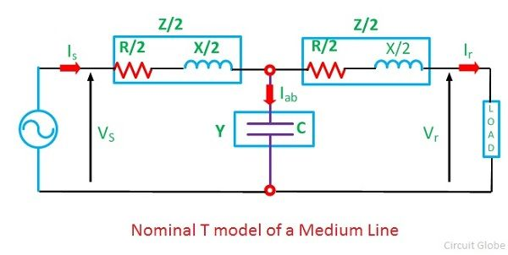

Here,

Series impedance of the line Z = R + jX  
Shunt admittance of the line Y = jwc  
Receiving end voltage = Vr  
Receiving end current = Ir  
Current in the capacitor = Iab  
Sending end voltage = Vs  
Sending end current = Is

Sending end voltage and current can be obtained by application of KVL and KCL. to the circuit shown below

[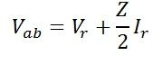](http://circuitglobe.com/wp-content/uploads/2016/05/first-eq-compressor.jpg)Current in the capacitor can be given as,

[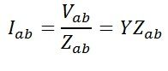](http://circuitglobe.com/wp-content/uploads/2016/05/second-equ-compressor-2.jpg)By Kirchoff’s current law at node a,

[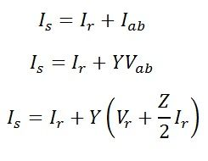](http://circuitglobe.com/wp-content/uploads/2016/05/third-equ-compressor-1.jpg)

By Kirchoff’s voltage law

[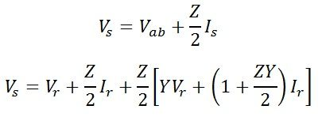](http://circuitglobe.com/wp-content/uploads/2016/05/msdium-line-forth-compressor.jpg)

Equation of Sending end voltage Vs and current Is can be written in the matrix [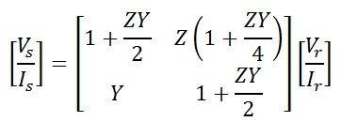](http://circuitglobe.com/wp-content/uploads/2016/05/medium-line-sixth-compressor.jpg)

[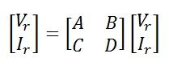](http://circuitglobe.com/wp-content/uploads/2016/05/medium-seven-compressor.jpg)

Hence, the ABCD constant of the nominal T-circuit model of a medium line are

[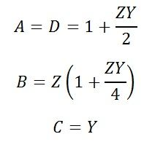](http://circuitglobe.com/wp-content/uploads/2016/05/medium-8-compressor.jpg)

The phase diagram of the nominal T-circuit is shown below. It is drawn for a lagging power factor.

